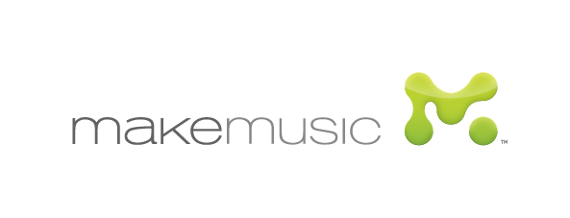

Copyright and Trademarks
©Copyright 2013 MakeMusic, Inc. All Rights Reserved.
Except as specifically permitted herein, you may not reproduce any portion of the content of this website without prior written permission from MakeMusic, Inc.
Trademarks
MakeMusic, Inc. owns the registered trademarks in the United States for Allegro®, Dolet®, Finale®, Finale Allegro®, Finale NotePad®, ®Finale PrintMusic®, Finale Reader®, Finale SongWriter®, Finale Viewer ®, FinaleScript®, Garritan Personal Orchestra®, Gigapiano®, Gigasampler®, Gigastudio®, HumanPlayback®, HyperScribe®, Intelligent Accompaniment®, MakeMusic®, MicNotator®, ScoreManager®, SmartMusic®, SmartMusic Impact®, StudioView®, SmartFind and Paint®, SampAlign Sonic Morphing®, TempoTap®. In addition, the names Finale®, Finale NotePad®, Finale PrintMusic®, Finale SongWriter®, Finale Viewer ®, Intelligent Accompaniment®, MakeMusic®, SmartMusic® and The Art of Music Notation® have been protected in some foreign countries. We have applied for trademark registration in the United States for SmartMusic InboxTM, Finale SongBookTM, GarritanTM, Garritan Classic Pipe OrgansTM, Garritan Concert & Marching BandTM, Garritan Instant OrchestraTM, Garritan Jazz & Big BandTM and Garritan World Instruments TM. All other trademarks, product names, and company names and logos appearing on makemusic.com are the property of their respective owners. These trademarks include, but are not limited to the following: Microsoft® Windows® is a trademark of Microsoft Corporation. Netscape® is a trademark of Netscape Communications Corporation. Macintosh® is a trademark of Apple Computer Inc. Boomwhackers® is a registered trademark under license to, and Chroma-Notes™ is a trademark under license to, Whacky Music, Inc.

